in Memory Of

Duane Henry Schultz
Davie, Florida
Apr 21, 1939 - May 6, 2017

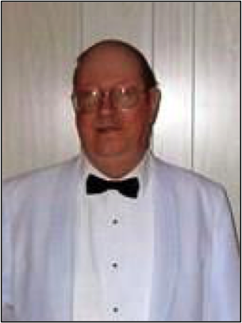

Duane Henry Schultz, 78 of Davie, Florida entered into rest on Saturday, May 6, 2017. Funeral arrangements are under the direction of Forest Lawn Funeral Home South in Davie, Florida. A Lifetime member of The Hollywood West Elks Lodge #2365 of the Benevolent and Protective Order of Elks, Duane served in many roles at the Lodge. He was formally a Trustee, Treasurer and House Committee. Chairman to name a few. Duane will truly be missed.

